**Patriot Missile (1991)**

**What happened?**

The Gulf War operations, which started at 2 August 1990 and took end on 28 February 1991, led to the accumulation of troops and defense on Saudi Arabia. In this war participated a coalition force from 35 nations commanded by the United States against Iraq, due to Iraq's invasion and annexation of Kuwait. During this was war the **US Patriot missile defense system was used in combat for the first time.

**What is The Patriot?**

The Patriot is an Army surface-to-air, mobile, air defense missile system. Since the mid-1960s, the system evolved to defend against aircraft and cruise missiles as well. During the Guf War it was being developed to counter short-range ballistic missiles.

This system was designed to operate against Soviet missiles traveling at speeds up to about 2448 km/h. To avoid detection it was designed to be mobile and operate for only a few hours at one location.

The weapons control computer of the Patriot obtains target information from the system's radar. The radar sends out electronic pulses that scan the air space above it. The pulses that actually hit a target are reflected back to the radar system and interpreted. If the object that was found is recognized as a missile, the Patriot is instructed to intercept it.

**What was the failure impact?**

On the day 25 of February, one of the Patriot missile systems failed to intercept and destroy an enemy missile. Subsequently this one ended up hitting Army barracks, **killing 28 Americans and making over 100 injuries.

**Why did it happen?**

Since it was the first time the Patriot was being used to defend against Scud missiles, which were being used by the Soviet Army and fly at approximately 6035 km/h, the Army still was learning how to track and intercept them. Besides this, the Patriot system was equipped with a data recorder that would save the overall system performance information, but it was not being used.

Two weeks before the incident, the Army officials received Israeli data that notified them that, after 8 consecutive hours of operating the Patriot system, this one was showing some loss in accuracy.

The system that was active during the fail of the missile interception, was working uninterruptedly for more than 100 hours. The Patriot failed its purpose due to a software problem in the weapons control computer, which "led to an inaccurate tracking calculation that became worse the longer the system operated", according to a report about the accident.

The new and improved software system arrived to Saudi Arabia on February 26, the day after.

The whole problem on the accuracy was the fact that velocity is a real number that cannot be represented completely with decimal numbers and the fact that although the time on the system is measured in tenths of second, it is shown as an integer. Therefore, because of how the Patriot software calculated and because the registers were only 24 bits long, the conversions and calculations could not be more precise than 24 bits. When the system kept operating for so long, the error started accumulating leading to a loss of precision.

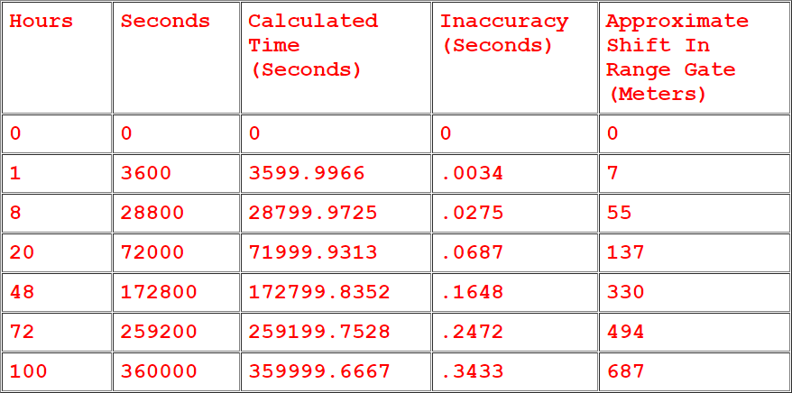

Fig. 1 – Uninterrupted Run Time Effect on Patriot system.

**How to avoid it?**

The software was changed in order to compensate for the inaccurate time calculation. However, the officials never announced to the public what were the changes. Nonetheless, it can be easily seen that the biggest mistake was not using the data recorders. If these were used, the problem in the accuracy could have been discovered and solved earlier and 28 lives would have been saved.

Besides the data recorder, it can be pointed that, when developing software for something as critical as missile systems, the software engineers must be focused on not letting such problems go unsolved.

At last, the officials can be blamed as well, since they did not take in attention the recommendations that the Patriot system should be turned off and on every few hours, which would reboot the computer's clock, setting the time back to 0.

**Reference:**

<https://www.cs.drexel.edu/~introcs/Fa10/notes/07.1_FloatingPoint/Patriot.html?CurrentSlide=10>

<https://embeddedgurus.com/barr-code/2014/03/lethal-software-defects-patriot-missile-failure/>

<https://www.nytimes.com/1991/06/06/world/us-details-flaw-in-patriot-missile.html>

<http://www-users.math.umn.edu/~arnold/disasters/patriot.html>

<http://www.dtic.mil/dtic/tr/fulltext/u2/a344865.pdf>